**Introduction**

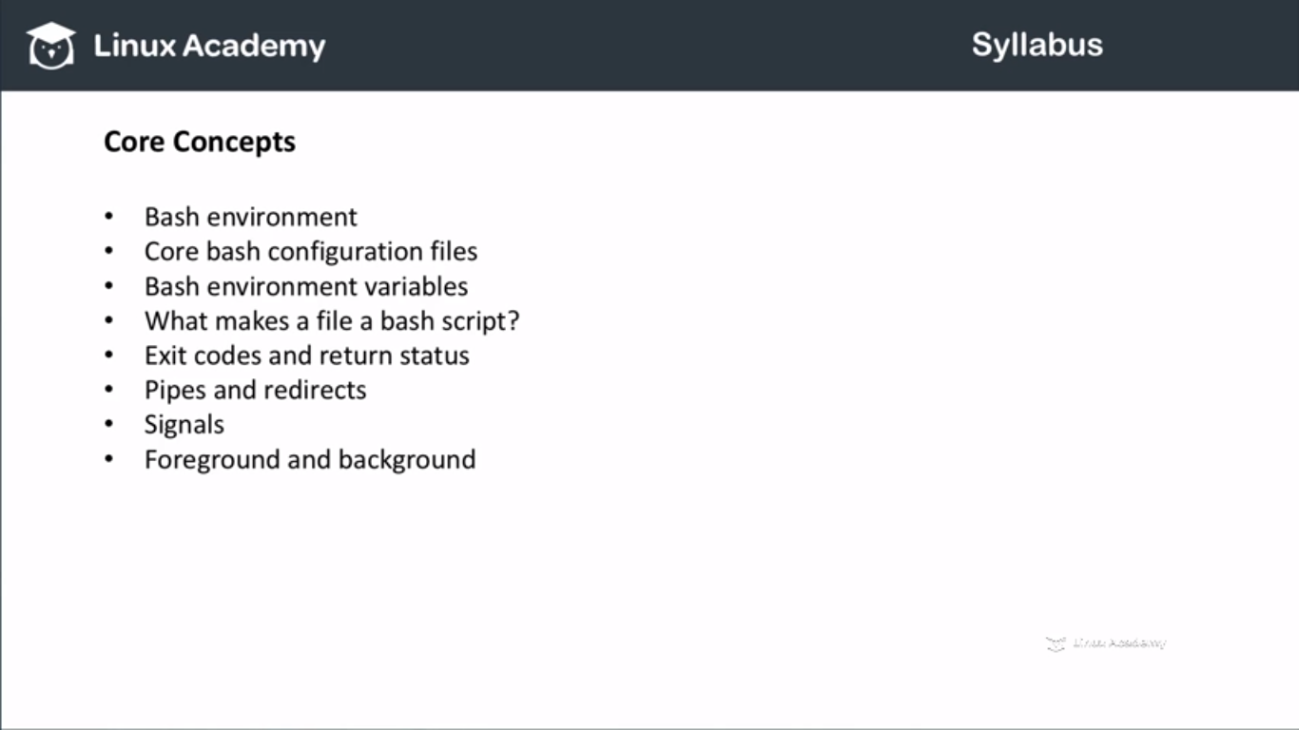

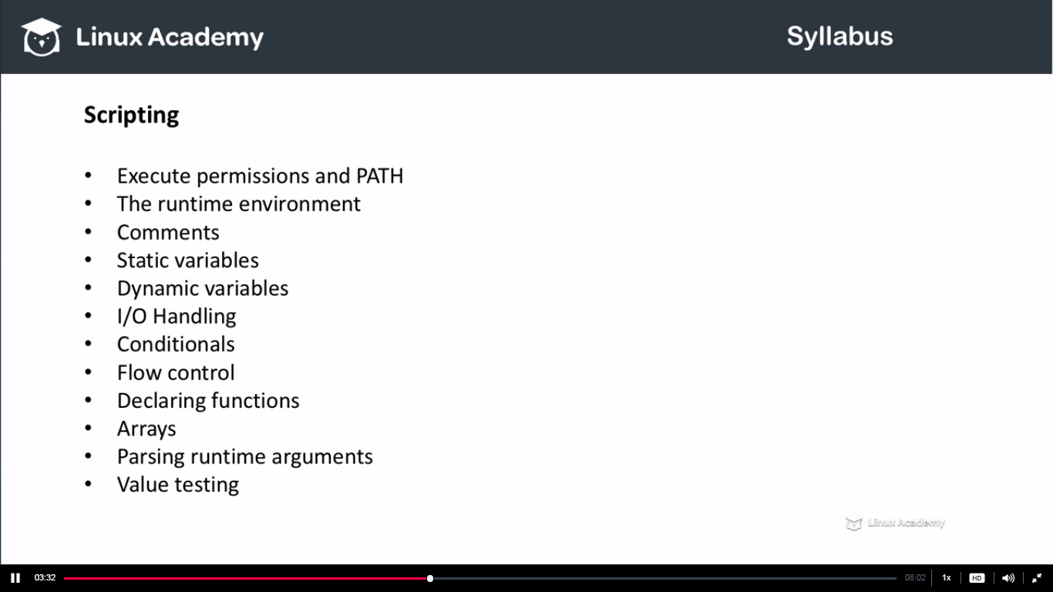

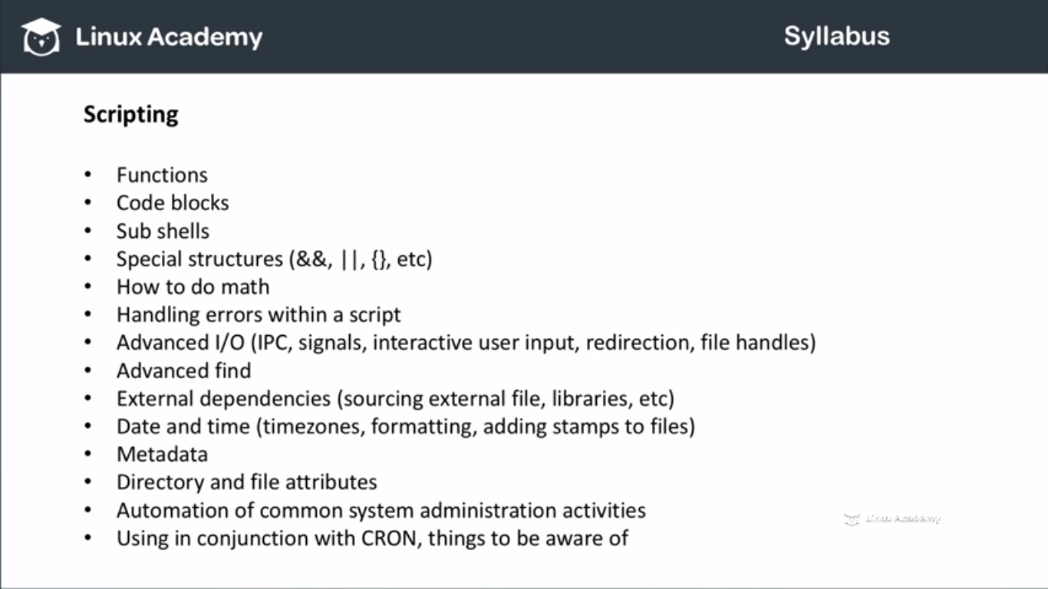

**###########################################################**

**Core Concepts**

**Lecture: Bash Files - .bash_profile**

**$ sign means the current value.**



**In this $PATH means the current value of the PATH variable.**

**Lecture: Bash Files - .bashrc**

**In last lecture we talked about .bah_profile file file. When you login after that if you do ls-al you see a lot of local bash configuration files for the particular user who logged in. So in this lecture we are going to see the .bashrc file.**

**Bash_profile file is for when you login to a system and you are typing a username and password. Bashrc gets executed simply before the command prompts comes up or it runs when you starts a new bash instance by typing bash in a shell.**

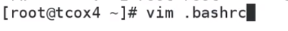

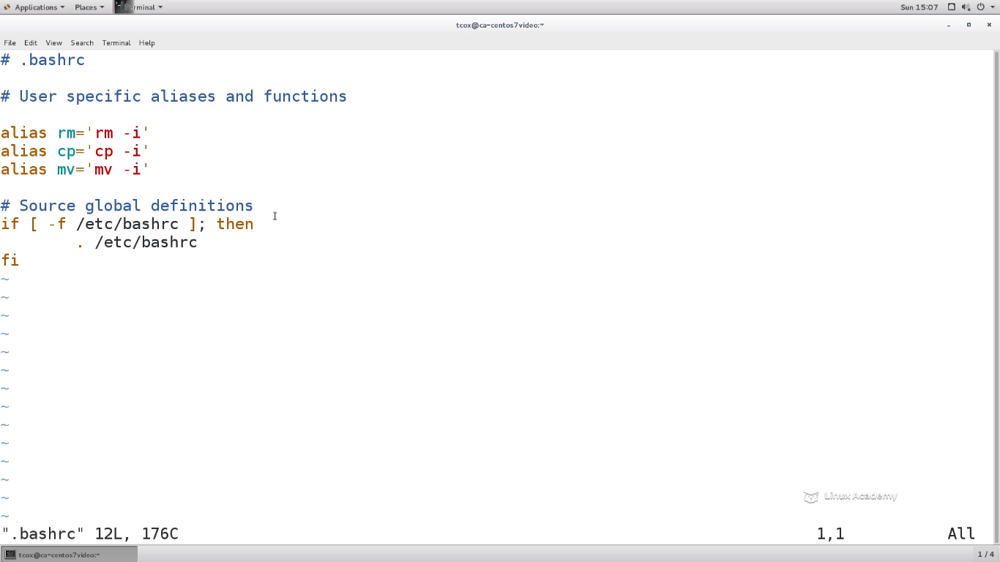

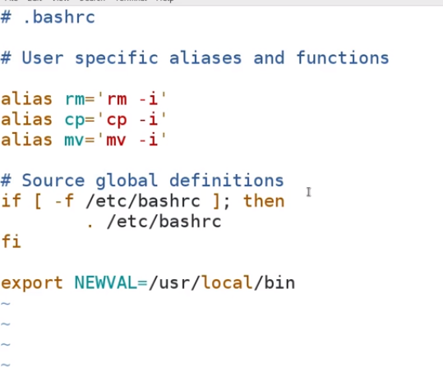

**Add the export line.**

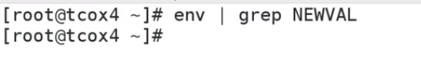

**So the NEWVAL doesn’t exist. So I can this script without logging out as we have to do with bash_profile. Here we don’t need to logout and then login inorder to run this .bashrc file. We can just create a new instance with just typing bash on the current commanline. Bash_profile either can be run directory or can be run after login again.**

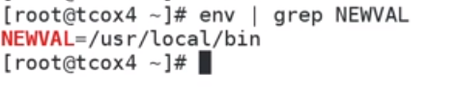

**IT worked after we just ran bash as it created a new bash session.**

**Now if I exit and re-run the**

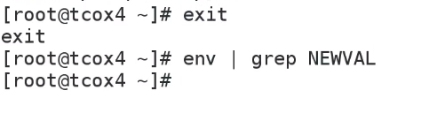

**I didn’t get the NEWVAL because it doesn’t exist in the previous bash shell because that .bashrc had not been run yet.**

**Lecture: Bash Files - .bash_history**

**Now lets discuss bash about another bash configuration file i.e .bash_history.**

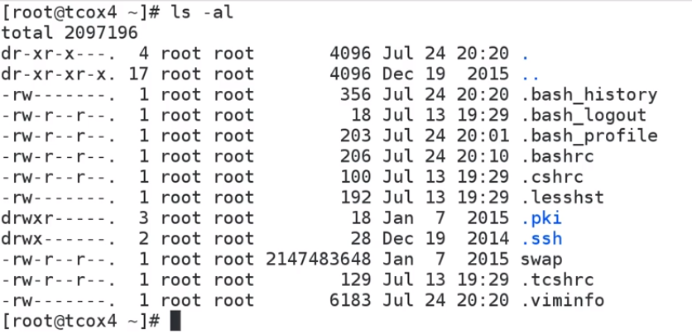

**Bashhistory simply is the history of what you have typed as this particular user in your shell**



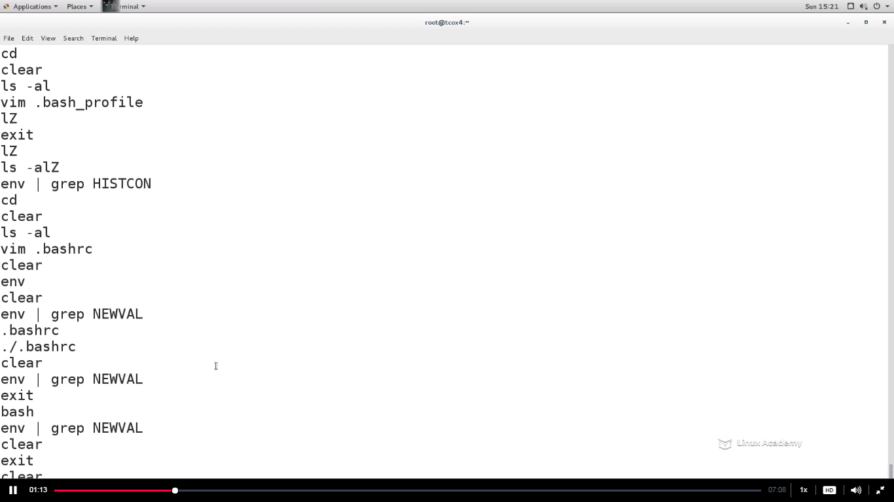

**We know know that all the commands we type gets updated in the bashhistory file of that user whose is logged in. IF we set our new password and we don’t want the sysadmin guys to see that then we need to put some condition so that the bashhistory ignores the password command.**



**We have added the ignorespace to the HistControl.**

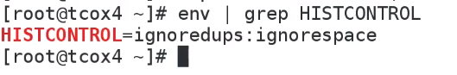

**So we see two things in the HISTCONTROL one is duplicates and next is the ignorespace.**

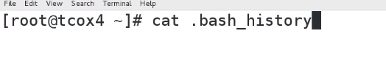

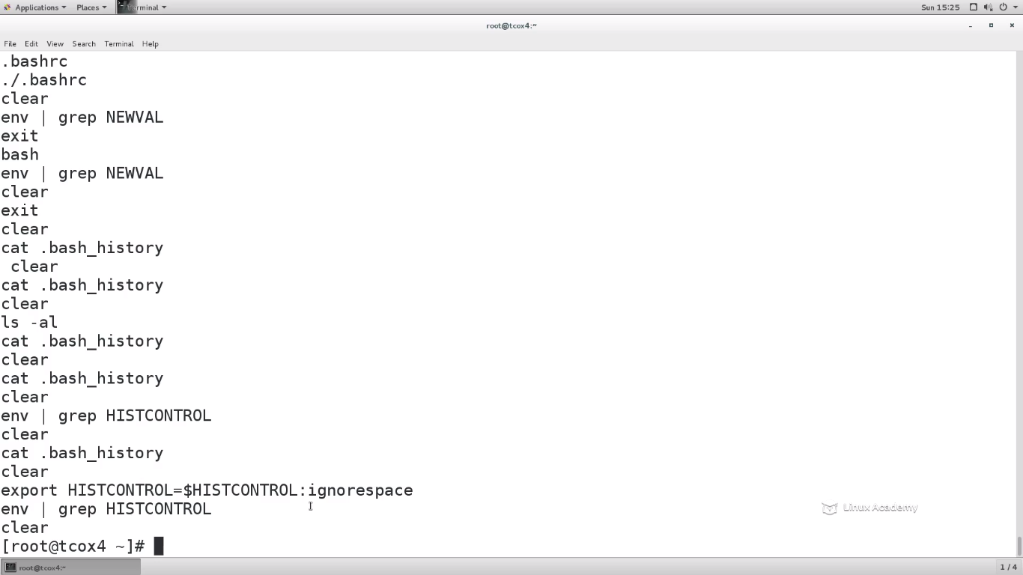

**Upto this time whatever we typed is there. Lets clear this all . So now if I don’t want a command to be copied in the history file what I need to do is to add a space in front of that command. So if you now type any command and put a space before it, it wont get captured in the history file. You can go and verify the same.**

**Lecture: What Makes a File a Shell Script?**

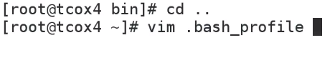

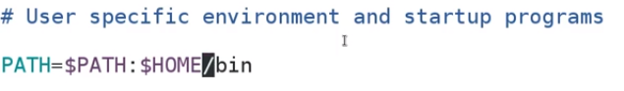

**This path has to be there for the following lectures. If this isn’t there put the entry and exit and relogin so that it works.**

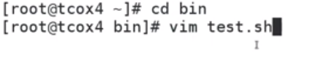

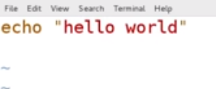

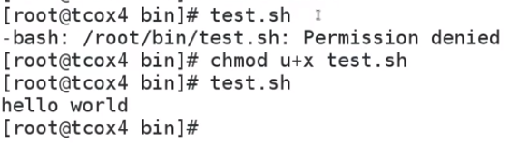

**So though it work, its not the right start to write a script. A script should be independent of the user’s shell. A shell script is so defined that it started particularly with a shell and then executes command within that shell so that its completely independent of the users shell that it started with in.**

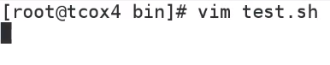

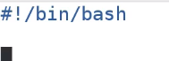

**This means that im going to write a script that is going to execute in the bash shell.**

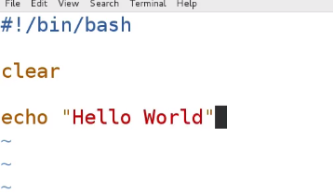

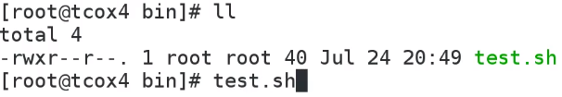

**O/p**

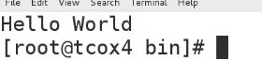

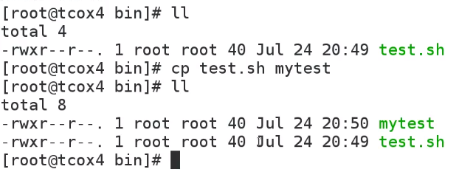

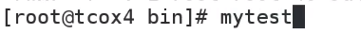

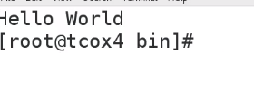

**Doesn’t matter if you want to put a .sh extention or not. Its jut good paractise to put it for visualization.**

**Lecture: Displaying Environment Variables in a Script**

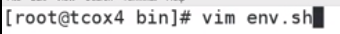

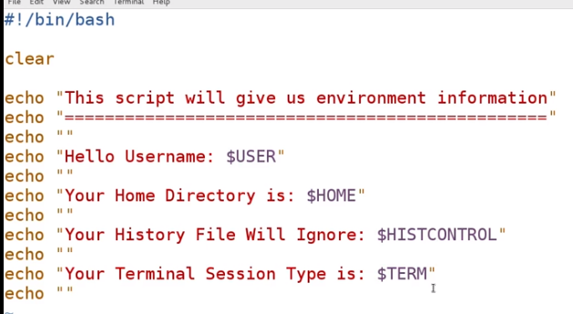

**The environment variables can be pulled in the shell with just putting the $sign before the variable name.**

**So we have env by which we can have pulled any information in there from the script. All the information which is displayed by the env command can be pulled in the script we create.**

**Do an env on the commandline and you will get the below**

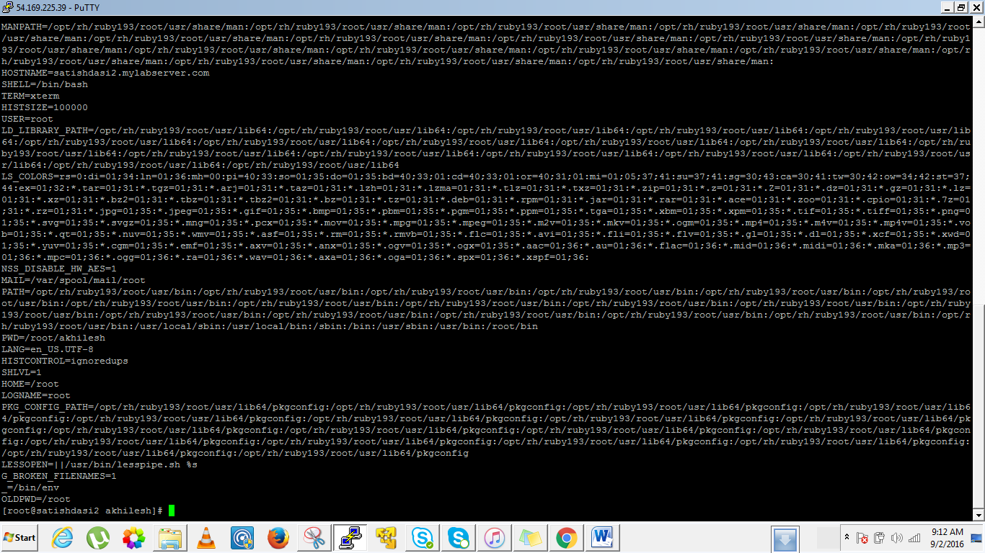

**Lecture: Using Variables on the Command Line**

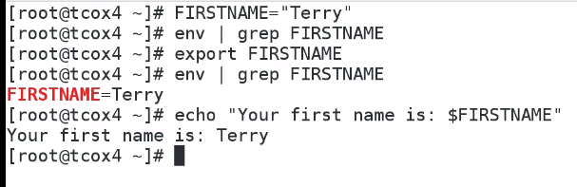

**IF we define a variable it wont show in the env unless you export it. Once you export it then it will be available for the use and we can use it as the other environment variable. IF you logout and then relogin you have to export it again else it wont be there in the env file.**

**We can combine the above two steps of defining a variable and exporting a variable by**

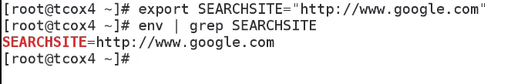

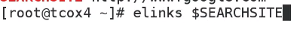

**Elinks is a text based browser. So If I do the above, it would take me to the google website as**

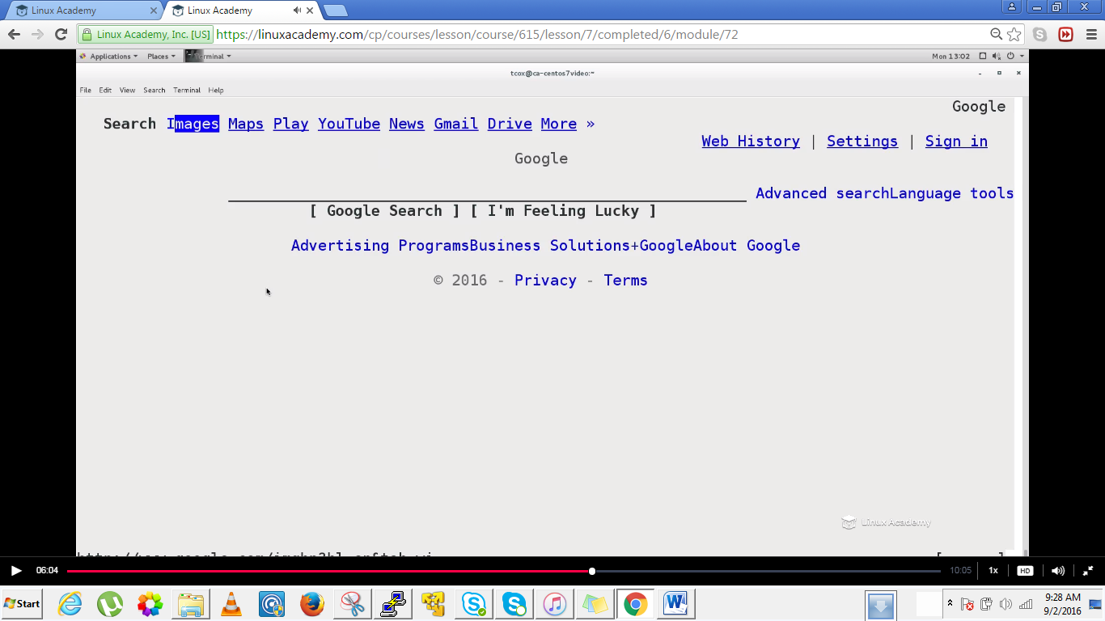



**Here we are setting the value of the TODAYSDATE and value we are assigning is from a command date.**

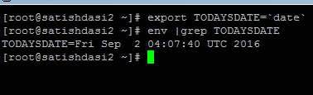

**IF we do a echo again on the TODAYSDATE its doesn’t show the current time because the value of the variable is assigned at the time of the export and that was the static value.**

**##################################################################**

**Lecture: Setting and Using Variables in Scripts**

**Vi variable.sh**

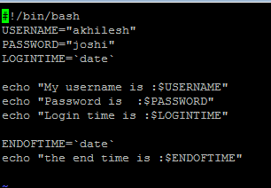

**Lecture: Comment Types and Structure**

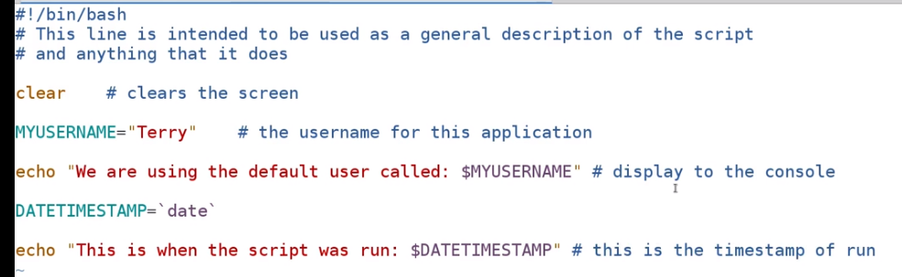

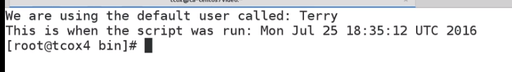

**There is no way of commenting a large group here as it is with C and other programming languages. We have to use only the # .**

**Lecture: Command Substitution**

**Vim substitution.sh**

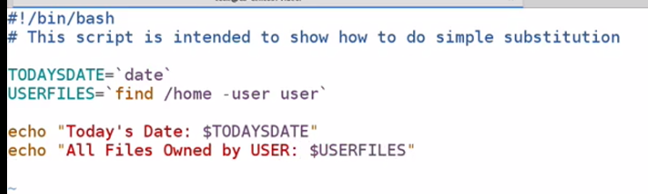

**This is one way of doing command substitution. The backtick(` `) is used if we want to assign a command output to a variable and this value would always be static.**

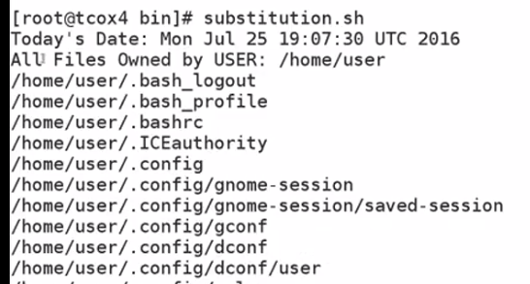

**Lets now edit our substitution.sh as we can do it in a different way.**

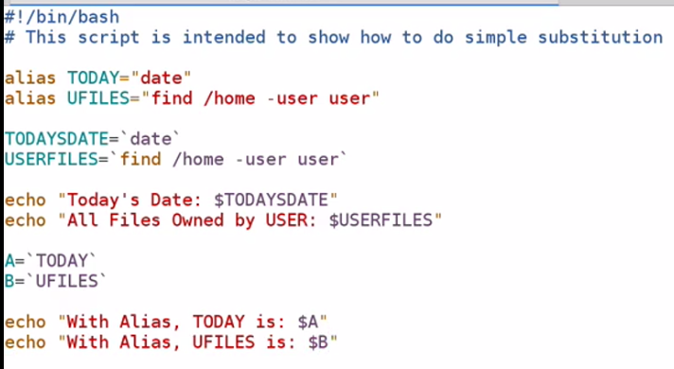

**Received error**

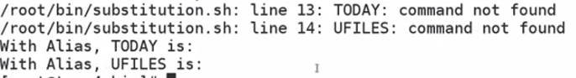

**Why is that?**

**add this to the top to expand the alias**

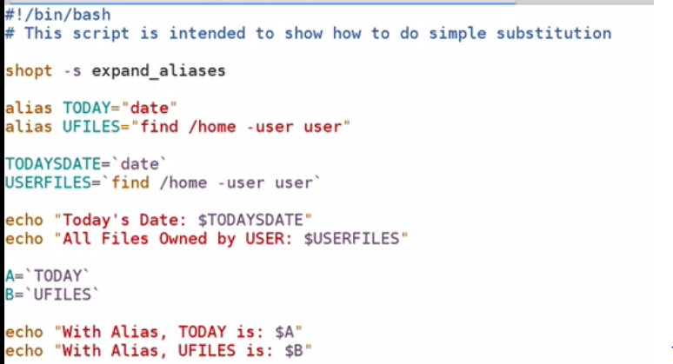

**Now run again and you would see you don’t find any errors.**

**Lecture: Exit Status**

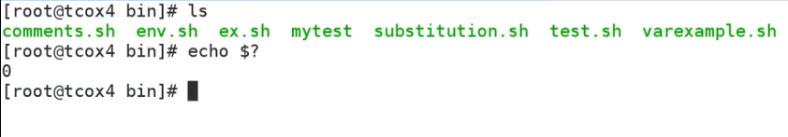

**We ran a command and it runs well. But if we know the status of a command we can do ‘$?’. This ‘$?’ gives us the status of the last executed command. 0 means success and other any numeric value mean error.**



**Vim error.sh**

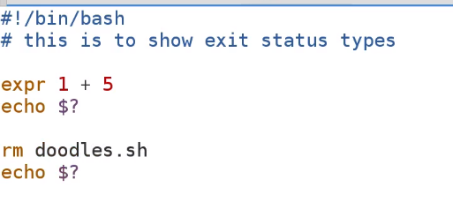

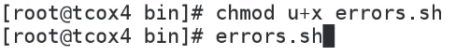

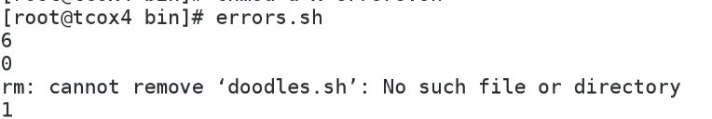

**Till now we see the shell turns every command and echo out the command status if its successful or not, howerver it runs every command . If we want to exit out of the shell if some command has exit status other than 0(or say there is some error), then do a set –e.**

**Set –e 🡪 what it does it that the minute it receives an error, it exits ourt of the shell.**

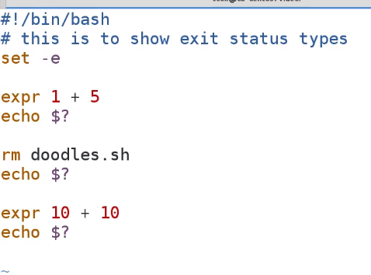

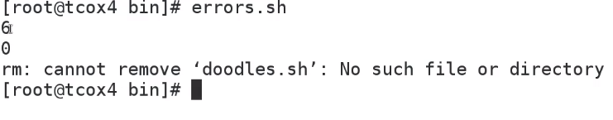

**So it doesn’t run the lines after the line which has an error. IT just exits out as soon as there is an error in any of the line.**

**Lecture: Arithmetic Operations**

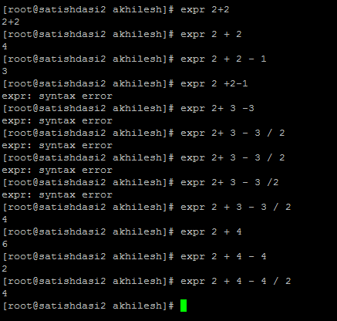

**We need to put a escape before a multiplication operator so that it doesn’t consider it the wildcard operator as the shell must do. So to let the shell know we are using the multiply symbol as a multiplication operator rather than a wildcard we need to put a escape sequence.**

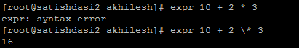

**We can do this as**

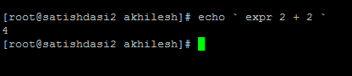

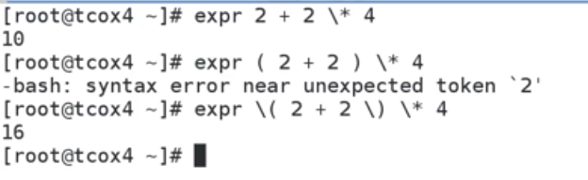

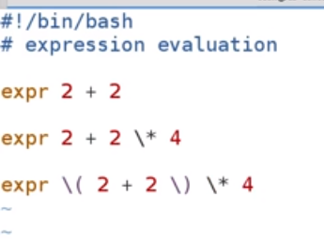

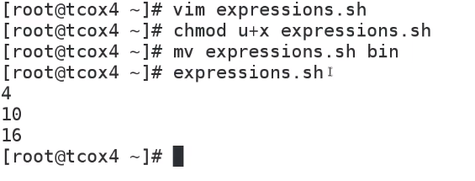

**Lecture: Global and Local Environment Variables**

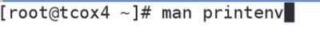

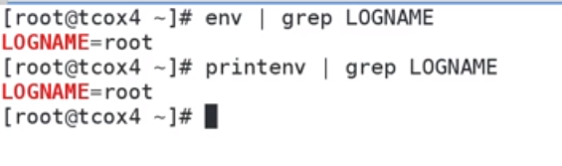

**IF we want to know the variable local to our local shell then we need to do a set command**

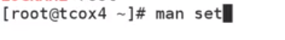

**IT will tell all of the environment variables that are specific to my session.**

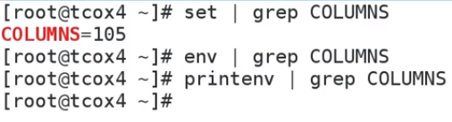

**We didn’t get any result of the env and printenv command because they aren’t limited to the session that im currently using.**

**Lecture: Special Characters - Quotes and Escapes**

**Escape character are used when we want to remove the special meaning from a character.**

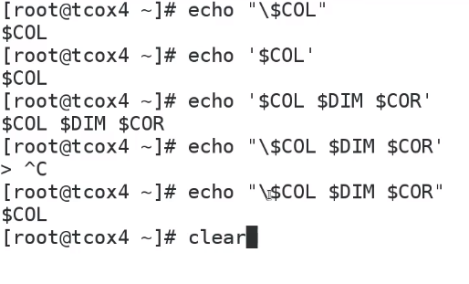

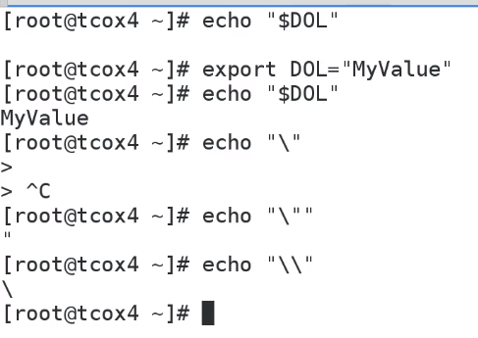

**There is offcourse the back tich character which is used to substitute the value of the entire command into our statement which is inside that backtich character.**

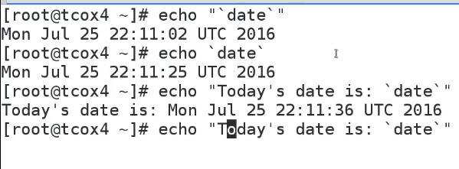

**IF you this**

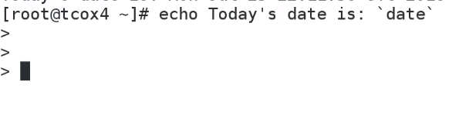

**IT starts treating it as a command statement. IT assumes as if the command isn’t completed.**

**Lecture: Using /dev/null**

**If you write something to /dev/null it goes away. It’s the clean way of redirecting output from an application , a script, crontab etc so that it doesn’t tries to go somewhere else. It doesn’t go to a file, it doesn’t go to a console , it doesn’t cause any issues because your are redirecting expected output to a device that simply ignores whatever that is.**

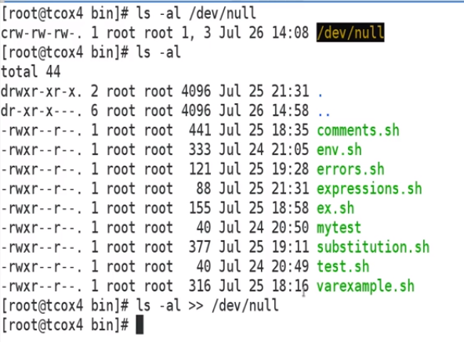

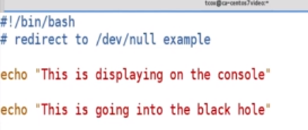

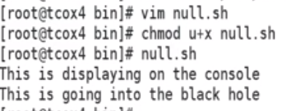

**You can do this both ways override or append but it’s a good practice to append rather than override.**

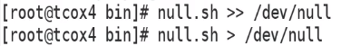

**Lecture: The Read Statement**

Up to now, we have provided our own input. Using the 'read' statement, we can prompt our users for it.



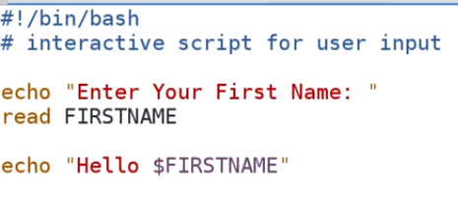

**Lets edit this a bit more**

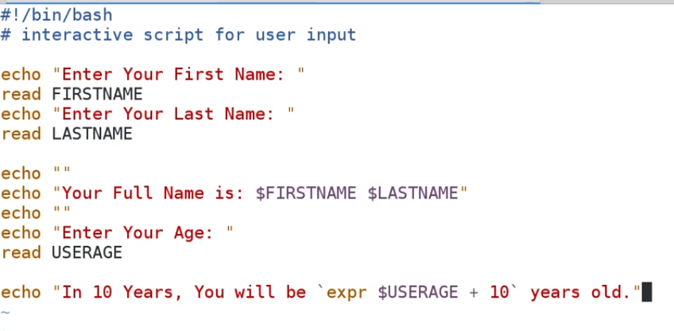

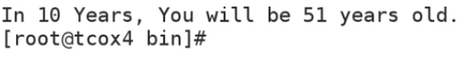

**IF you don’t give the arguments which are expected as**

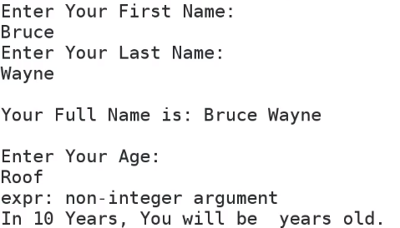

**IT gives an error as non-integer argument.**

**Lecture: Shell Expansion**

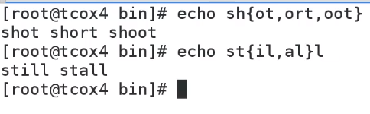

**These are short cuts which may use to save a bit typing.**

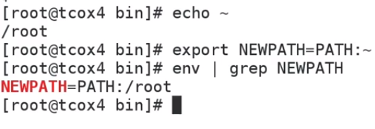

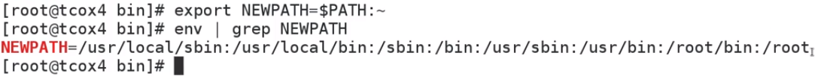

~ ->gives the home directory. If we “echo ~ “ it will give us the home directory whereas if we want to see our current directory then the shortcut is **$~+**

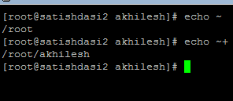

**If you want to see the previous directory you were in so do a** 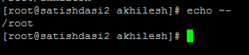

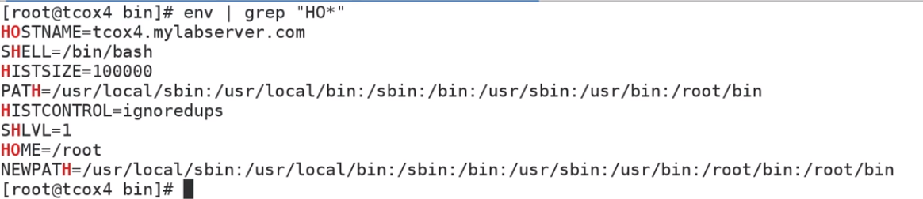

**Irrespective of doing the above we can do the below**

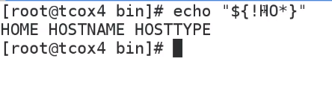



**Defining a variable and echoing it at the same time, above is the example.**

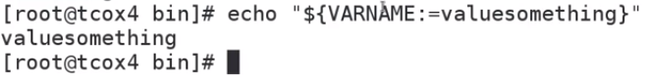

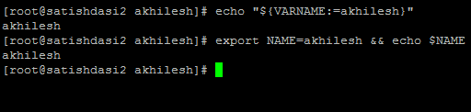

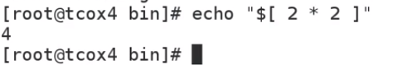

**There is no need to do put a escape before the multiplication operator.**



**Lecture: Types of Variables (Implicit vs. Explicit Definition)**

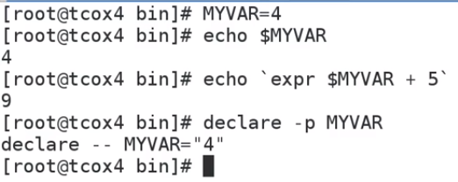

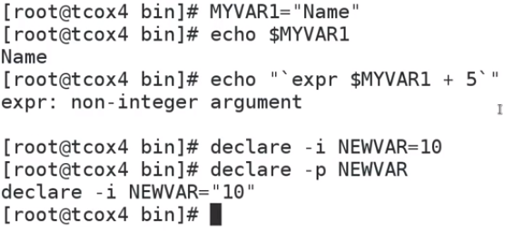

**i🡪 integer -p🡪prints what has been declared.**

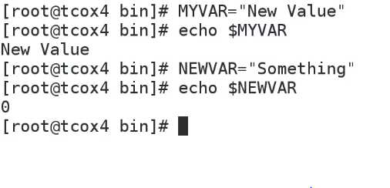

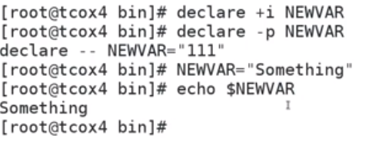

**Earlier we have explicitly declared NEWVAR as interger and when we gave a string value to it it converted it to 0 but if we want to change the variable type defined earlier to something else then we can do – declare +i NEWVAR.**

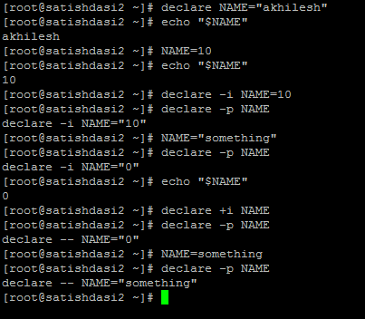

**We can declare variables as readonly**

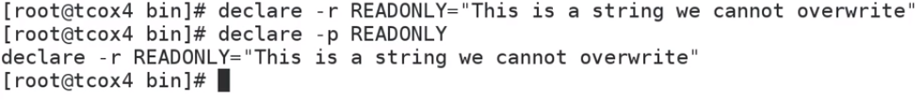

**IF we try to reassign the READONLY variable we would the below error**

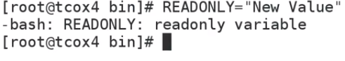

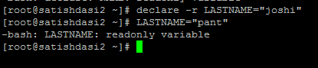

**Lecture: Arrays**

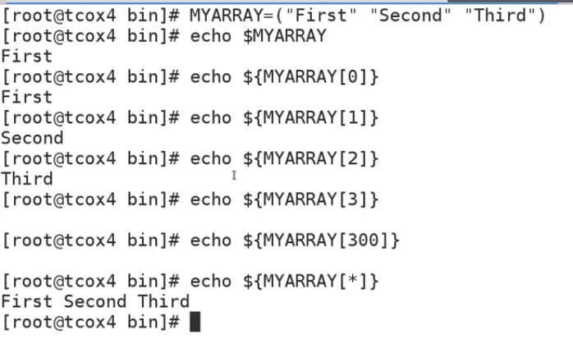

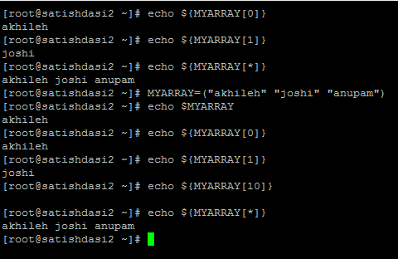

**Reassigning an array**

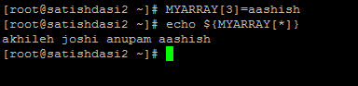

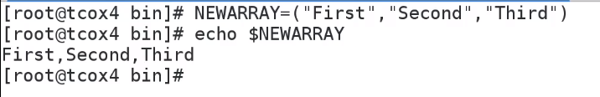

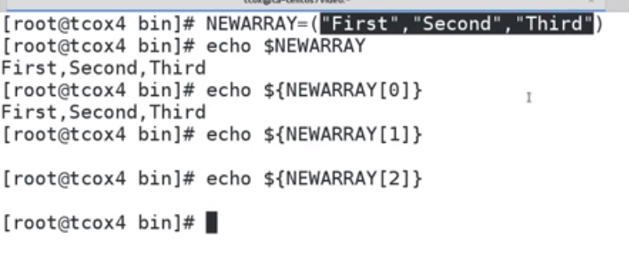

**We have commas that’s why it is treating the entire value separated by commas as a single value**

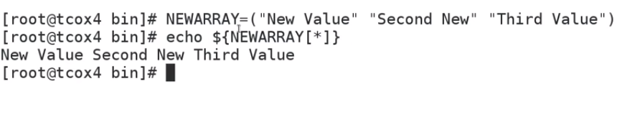

**We space delimit the values not the comma delimit.**



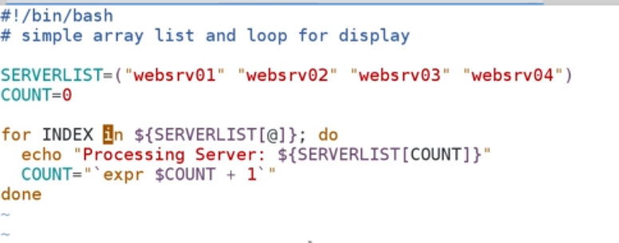

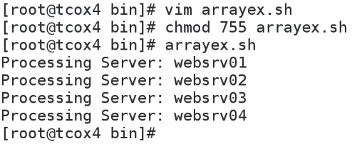

**Conditional Statements**



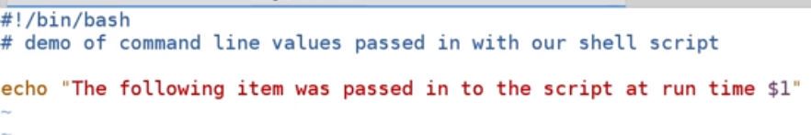

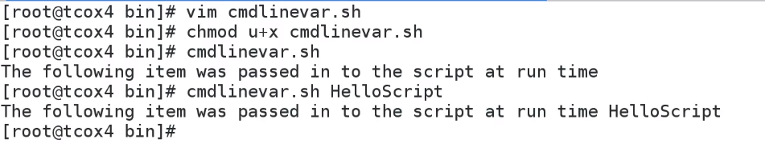

**We passed HelloScript at runtime which got displayed in the output.**

**If we give Hello Script as an argument at the runtime then the output would be**

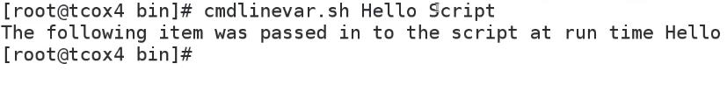

**However if we put the Hello Script in “” then the output would be**



**We can even pass backtick expression as an argument**

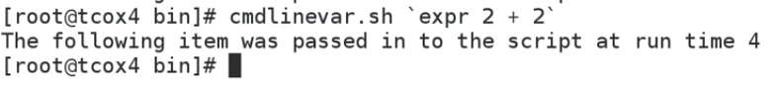

**If we want to pass two values then we have to make the below changes to the script**

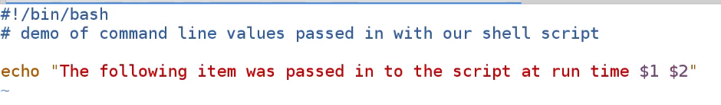

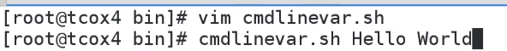



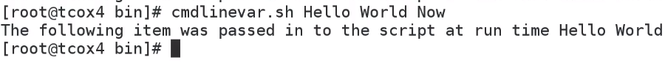

**Also I can assign the variables passed at runtime to other variable within our scripts as**

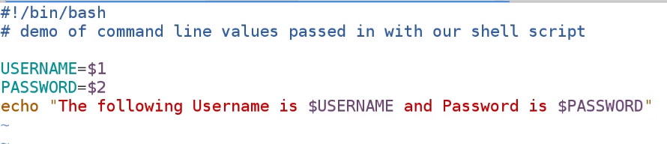

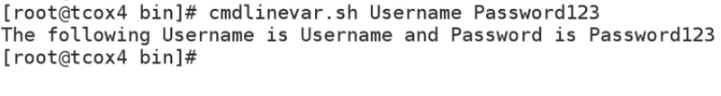

**Lecture: The If Statement**

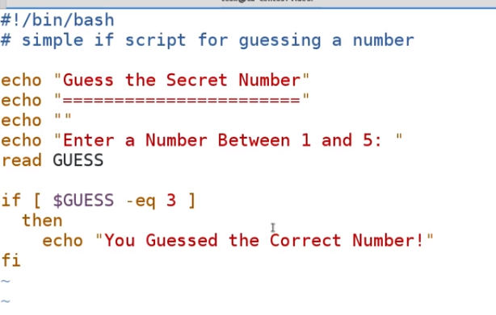

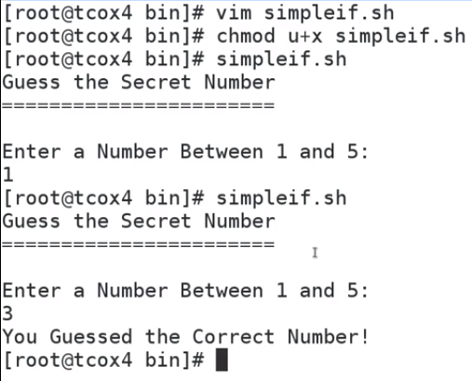

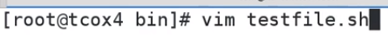

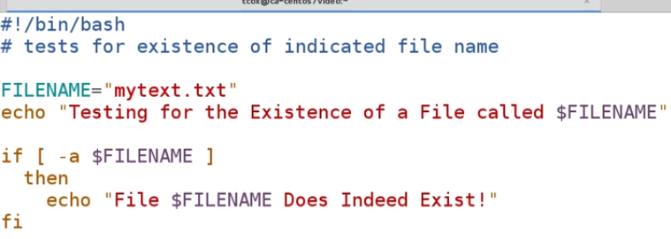

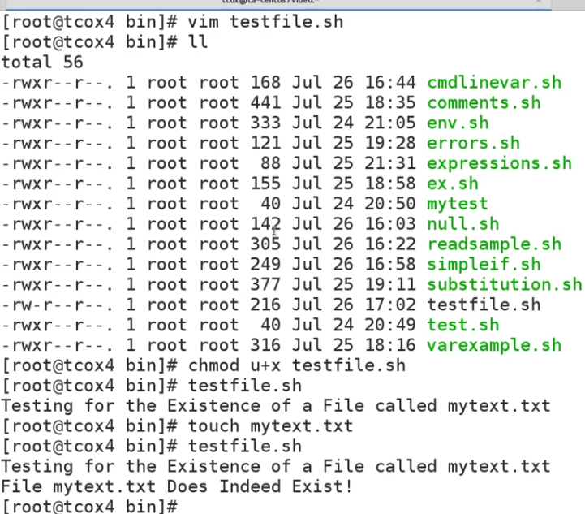

We can however do it like this.

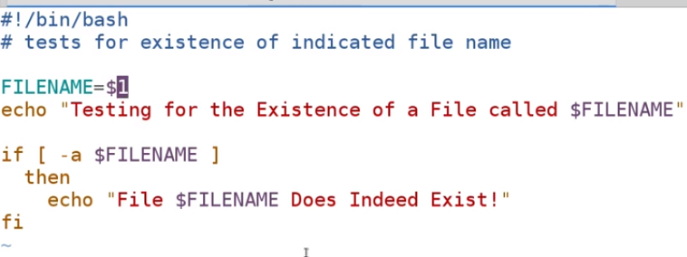

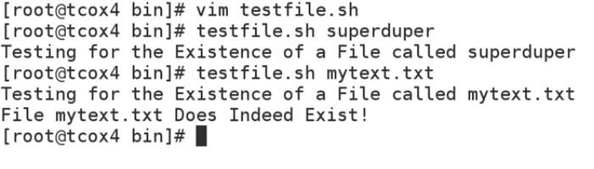

**IF now can we test for the non-existence of that file**

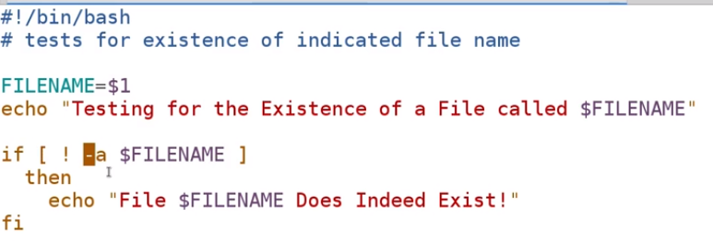

**So above we are testing for a file that doesn’t exists.**

**IF we want to test for 2 values then we can do the following.**

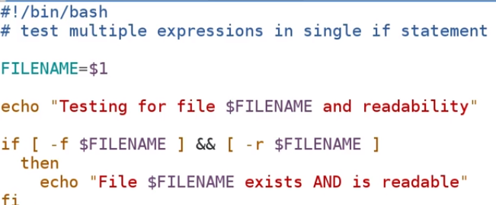

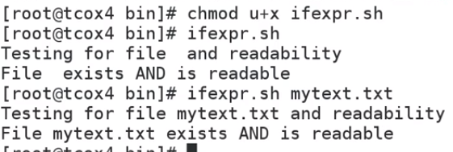

**Lecture: If/Then/Else**

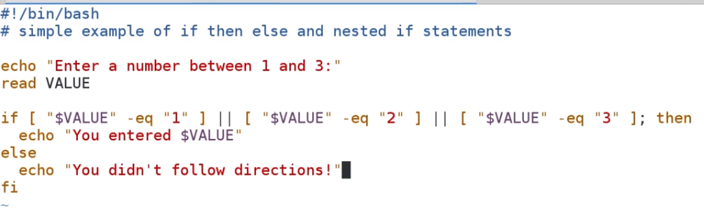

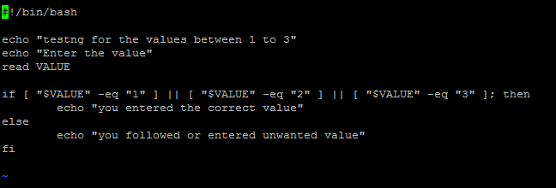

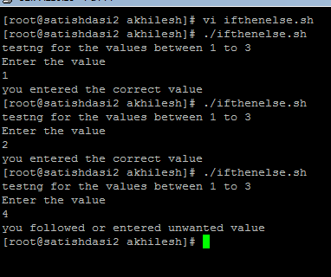

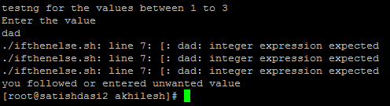

**So if we do not want the error message to be displayed then**

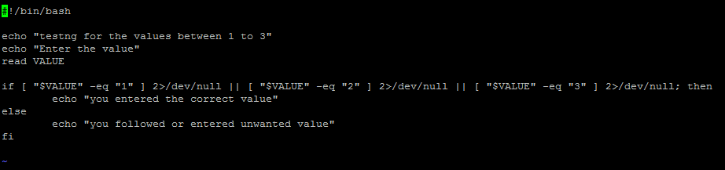

**2>/dev/null--🡪 2 stands for error output and we are redirecting it to the black hole(/dev/null)**

**We can do the above like the below**

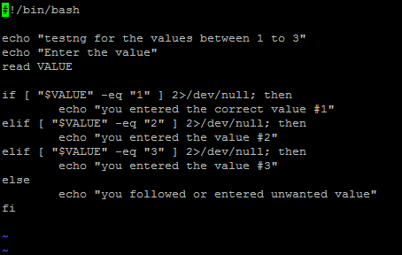

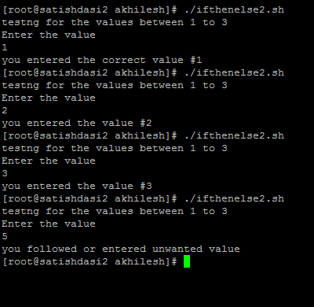

**Lecture: For Loop**

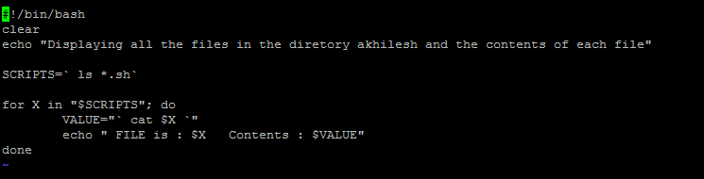

**Lecture: Case Statement**

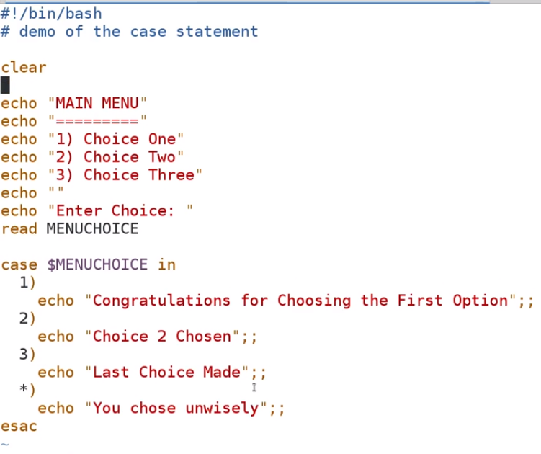

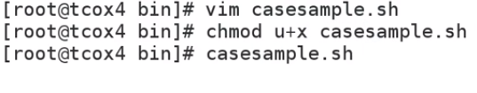



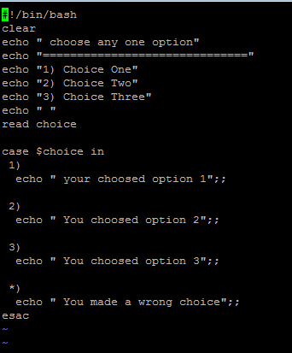

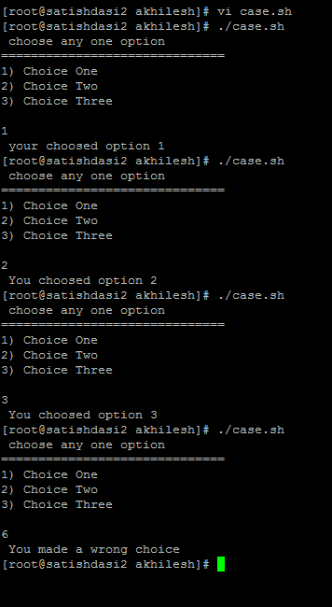

**Lecture: While Loop**

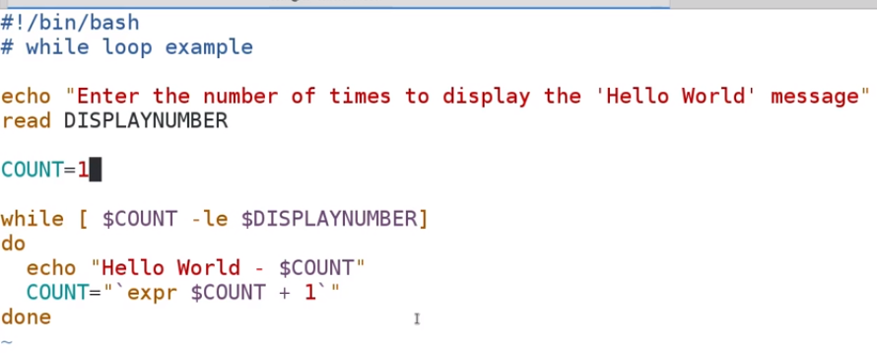

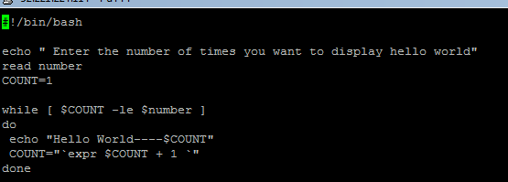

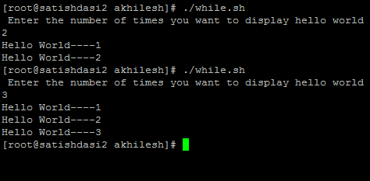

**Lecture: Execution Operators (&& and ||)**



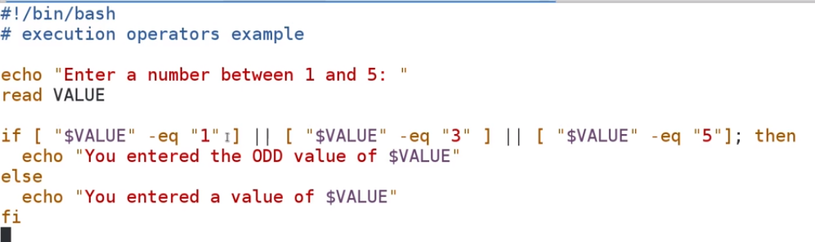

**Input and Output**

**Lecture: Reading Files**

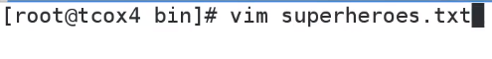





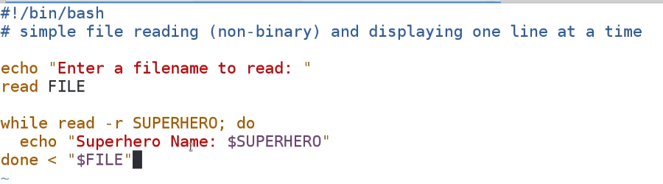

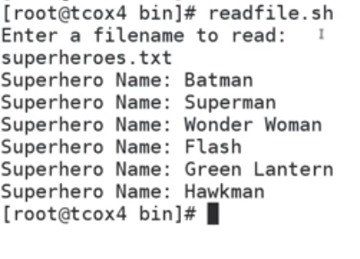

**We redirected a file which we entered on commandline into the while loop which read each line into the SUPERHERO variable and print the line.( read –r SUPERHERO--🡪 it means read the file redirected to the while loop line by line and store each line in the variable SUPERHERO variable)**

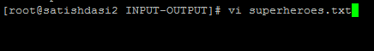

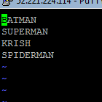

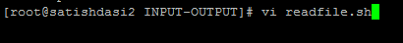

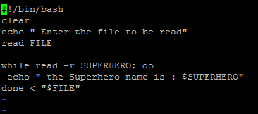

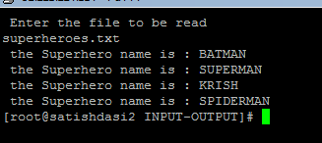

**Lecture: File Descriptors and Handles**

**File descriptors are a numeric representations of a file that we want to read, write or read and write to and we can determine how we open that file at runtime.**

**We need to enter a value greater then 3 as 0,1,2 are reserved values. So if we only want to write a file so we must do a** 

**If we want to read only then we must do a** 

**If we want both read and write to a file then we must do a** 

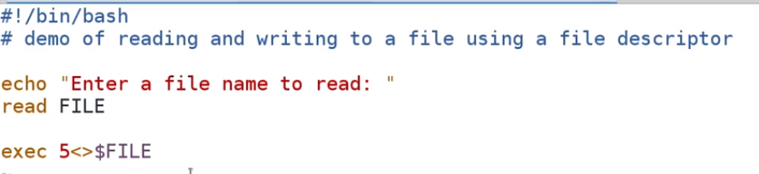

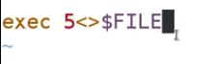**----By this statement we are saying that we are assigning a file descriptor to the variable(FILE) value that we entered in the command line .**

**And one more thing we have to use an & to denote a file descriptor**

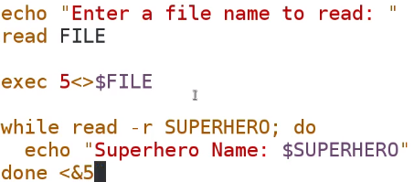

**So here we intending to read the file which we are going to pass on the commandline and for that we are redirecting the file descriptor i.e &5 and that is now representing our file and for that we have to use an & for this and then the numeric value that we have put with the exec command earlier(exec 5<> FILE).**

**And now we are writing to the file via the below statement using the file descriptor.**



So the main difference between using the file descriptor and the simple read which we did earlier was we opened a file descriptor and we want to close a file descriptor. Now we don’t have to close it but if we leave it on our system that file descriptor open then

1. **We wont be able to re-use it.**
2. **And we continue to do like this then we would be opening a lot many file descriptor on our system and we would eventually be fill up with a number of file descriptors that are available on our system. And we can cause our file system to have problems as it need file descriptors to do reads and writes on its own because this is largely how linux in the kernel deals with the files that it has to read and write to. Kernel uses file descriptors internally for doing the read and writes.**

**The whole file is this**

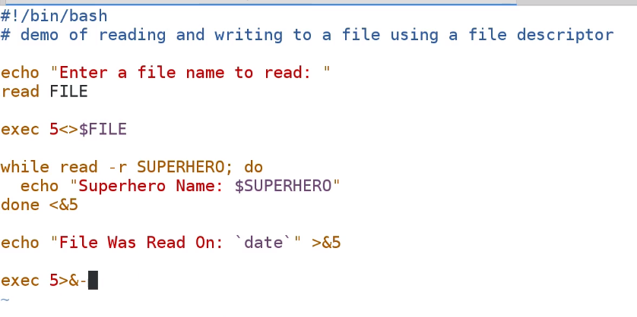

**What we are saying here is read a file FILE. Open up a file descriptor exec 5 for read and write a file FILE. Redirect a file FILE to the while loop and print each line. Then write to the file by redirecting the file descriptor >&5 and finally close the file descriptor exec 5>&-.**

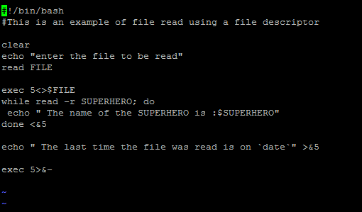

**Lecture: IFS and Delimiting**

**IFS stands for the internal field separator. IT determines how bash recognizes fields or boundaries when it interprets the character strings.**

**Default IFS is space as**

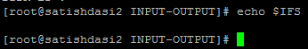

**We see the output of the echo IFS is blank because default value of IFS is space.**



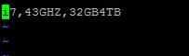

**This is the file which we will pass to the commandline to test the IFS DELIM script.**

**Now we will create the IFSDELIM.sh script as**

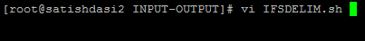

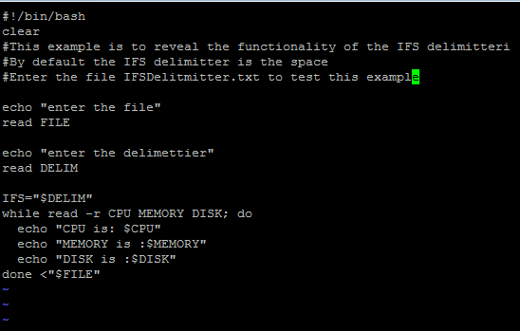

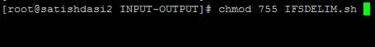



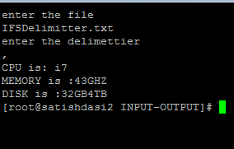

**I have tested this script by creating two other files as**

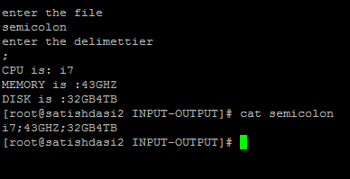

**Here the delimiter I used is the semicolon and the file is also the semicolon.**

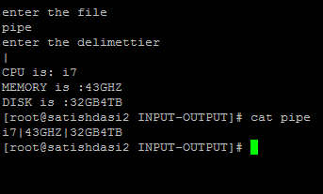

**Lecture: Traps and Signals**

**If we want our script not to break or suspend via CTRL+C or CTRL+Z then we use traps.**

**Trap takes two or more arguments. First is what you want to do when it the event happens and that has to be enclosed in single quotes . The second parameter is what is it we are trapping for. WE can trap for a command or the existence of a variable so that everytime a particular variable is used. In this case what we want to is to display a message anytime someone issues SIGNT which is an interrupt or CTRL+C or SIGTERM which is a kill command. We will put some message inside the first parameter of the trap command inside the single quote as**



**Also we want not to suspend this script via CTRL+Z so we can set a trap for this as well**



**SIGSTSTP🡪suspend.**

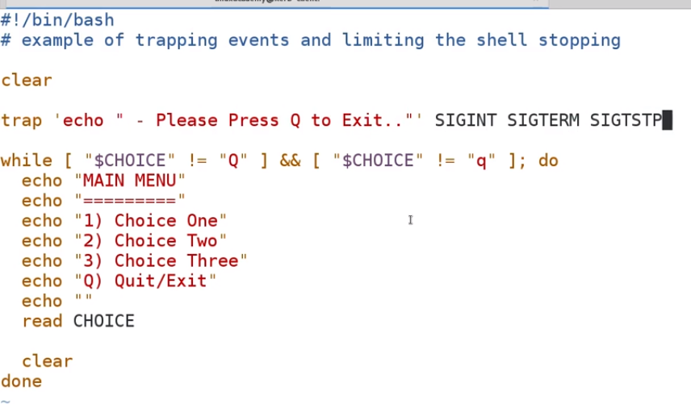

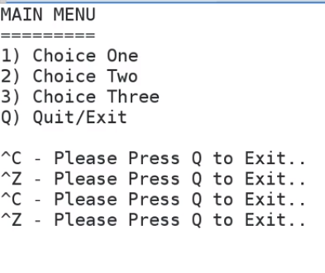

**So even after pressing the CTRL+Z its asking to press Q to quit.**

**Debugging and Error Handling**

[Debugging Your Script](https://linuxacademy.com/cp/courses/lesson/course/619/lesson/1/module/72)

**Lecture: Error Handling**

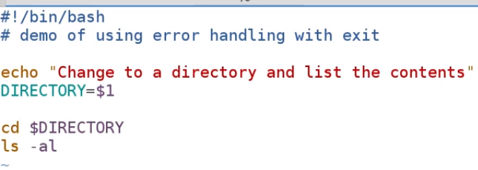

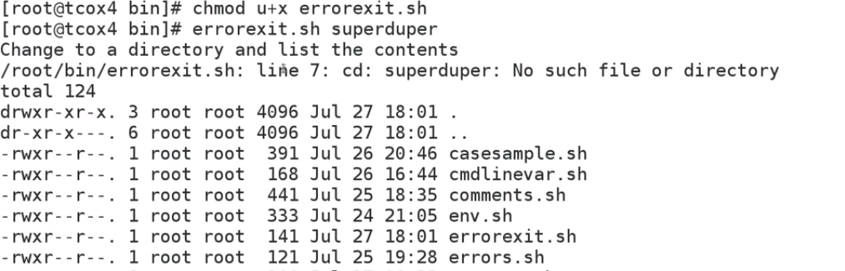

**So we got an error as that directory doesn’t exists. So we want to handle this error someway.**

**So we made the below changes to the script as**

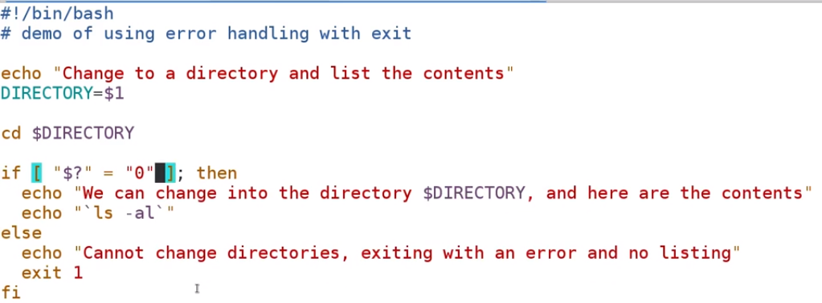

**So now we would be exiting if the last command status is a non-zero.**

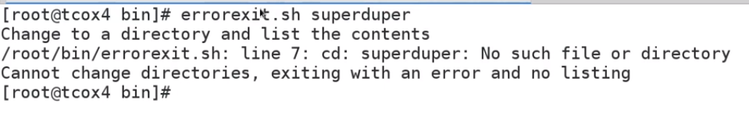

**This time it didn’t list the contents and exited out as the last command run was a failure.**

**Lets create a directory**

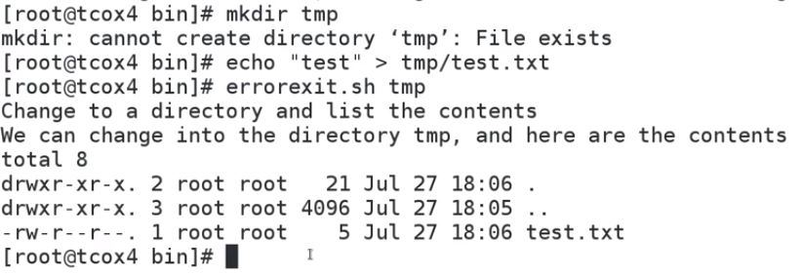

**This time it ran successfully.**

**One example**



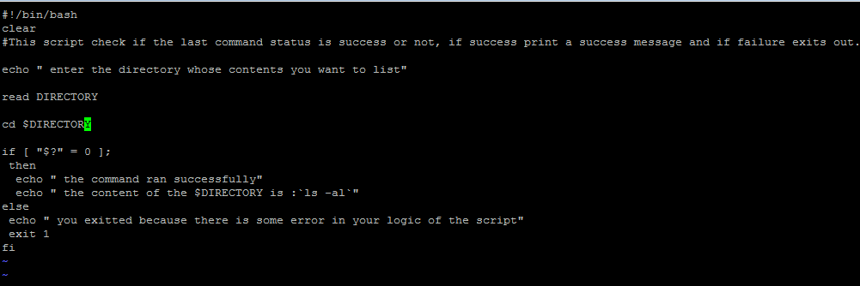

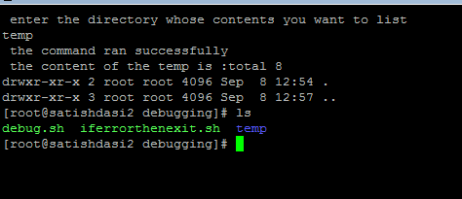

**Temp directory was there hence the script listed the contents of the temp directory. IF I re-run the script and give a directory which doesn’t exist then lets see what happens**

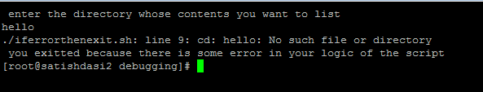

**IF we want to shortcircuit the error to a block hole(/dev/null) we can edit the script(2>/dev/null) and put the line at the below location**

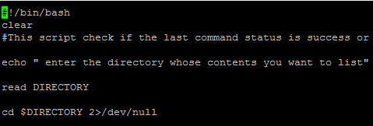

**And now re-run it as**

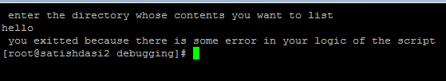

**Now we didn’t get error message “directory doesn’t exist “ as we were receiving it during the last run above. We can however check the last status of the command by**

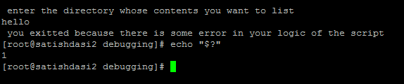

**So that means if the scripts run fine as per our logic. If the last command i.e cd $DIRECTORY works fine then it displays message and if not it displays an error message we mentioned in the else statement and exits out.**

**The whole script looks like**

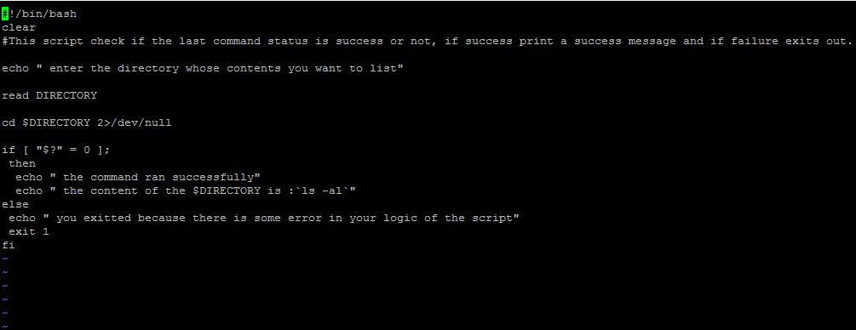

**Functions**

**Lecture: Simple Functions**

**A function can’t be empty.**

**We can’t have a blank function like this**

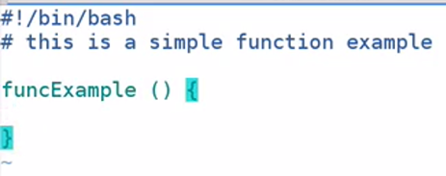

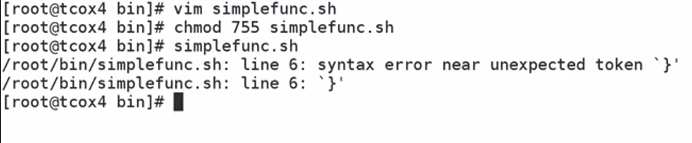

**IF we even write a null inside the function then we would not get an error as**

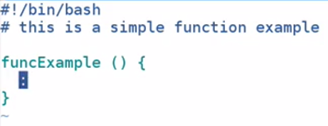

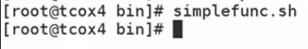

**It doesn’t did anything because first reason is we put a null inside the function and second we didn’t call the function.**

**Now lets define a function and then call it as**

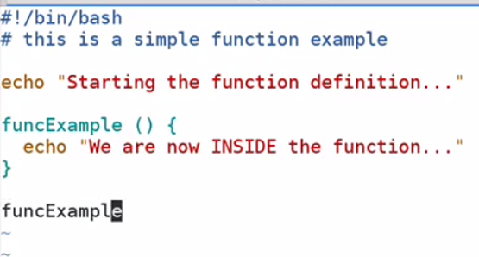

**IF we run our script it will run the function we defined**

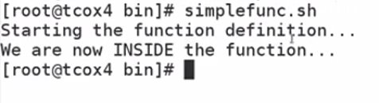

**WE see that we don’t have a semicolon at the end of the line inside the function as most of the languages like C, JAVA does. We don’t require semicolon here in bash. We only time we need an end of a line for a function in a bash shell script is when you are trying to define all it on a same line .**

**But if you don’t do it without an end of line as**

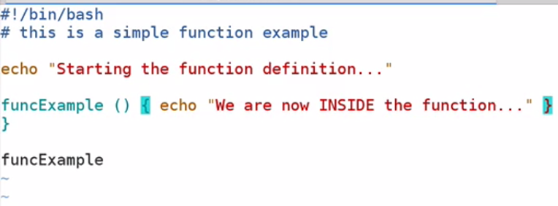

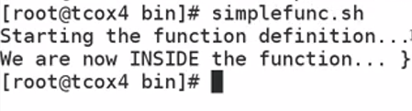

**What we need to do is we need to put a semicolon to denote the end of line. We are doing this because we are defining a function in a single line.**

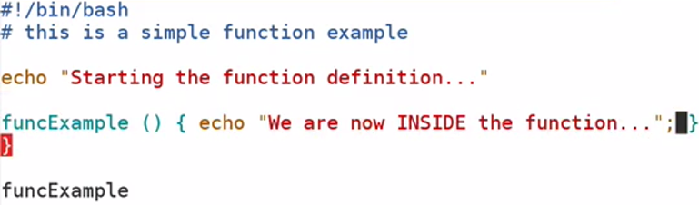

**Now if you re-run the script as**

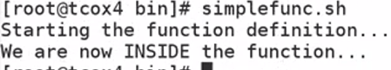

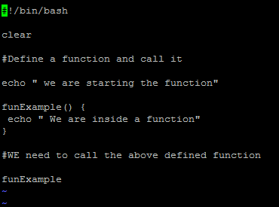

**IF we run the above script**

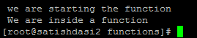

**Now lets do one more example as**

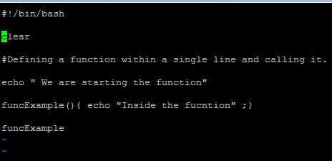

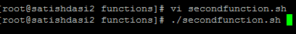

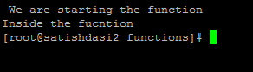

**Lecture: Structure of Functions in a Script**

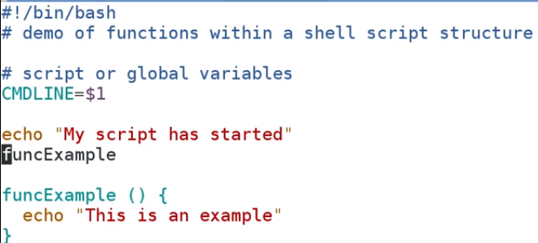

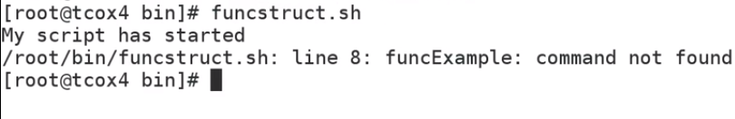

**This is because we are calling a function that hasn’t been defined first. We need to first define the function then only we must call it.**

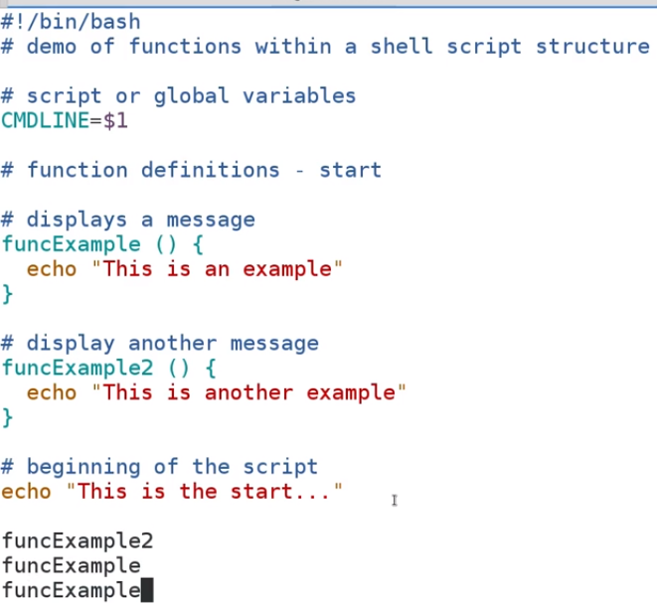

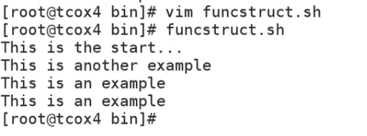

**Lecture: Variable Scope in Functions**

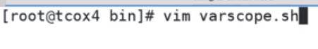

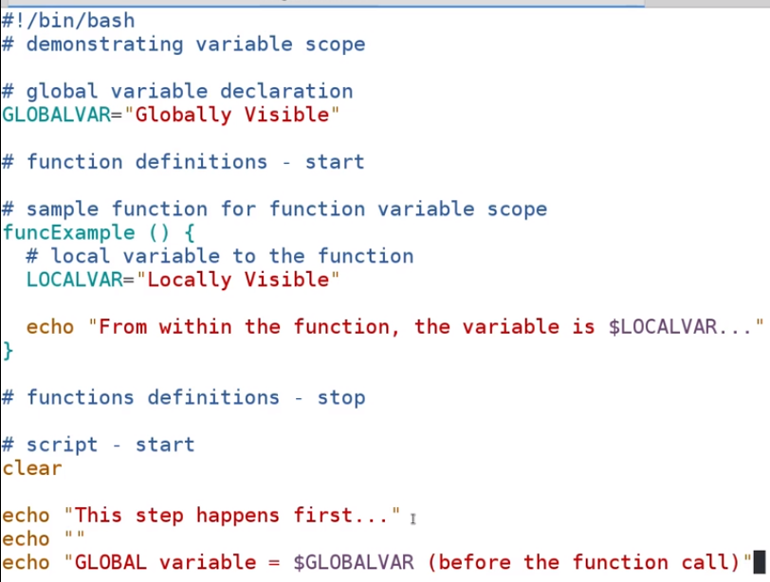

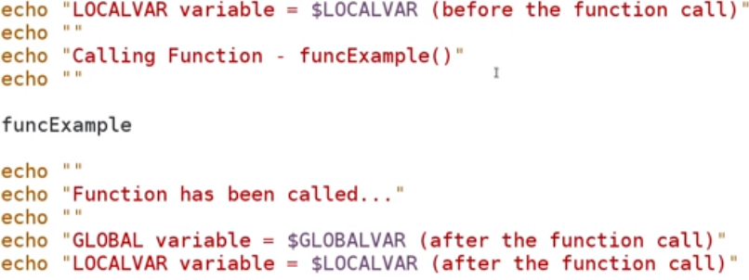

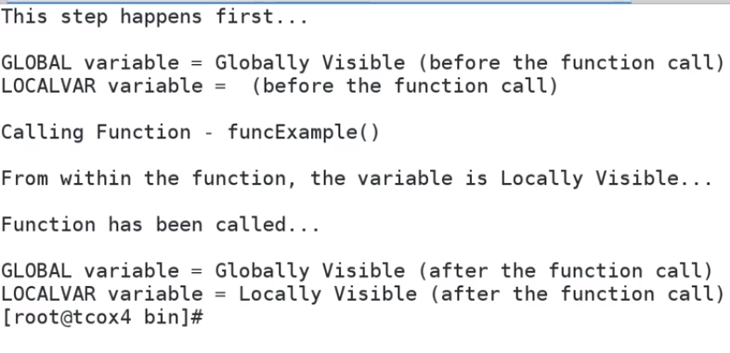

**Lecture: Functions with Parameters**

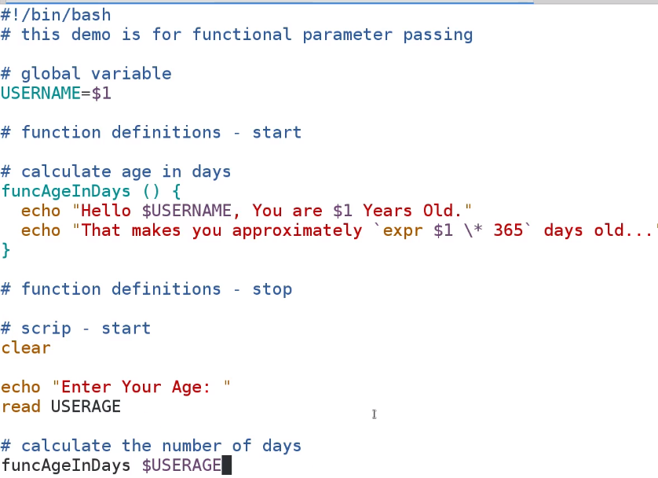

**So here we passed the variable USERAGE as a parameter to the function and the variable $1 inside the function is accepting the value of the variable passed in the parameter and its replacing the value with the value passed on the commandline.**

**O/P**

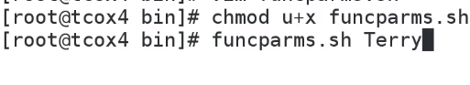

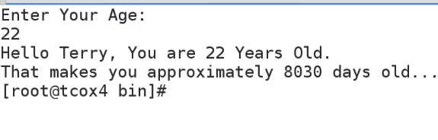

**Lecture: Nested Functions**



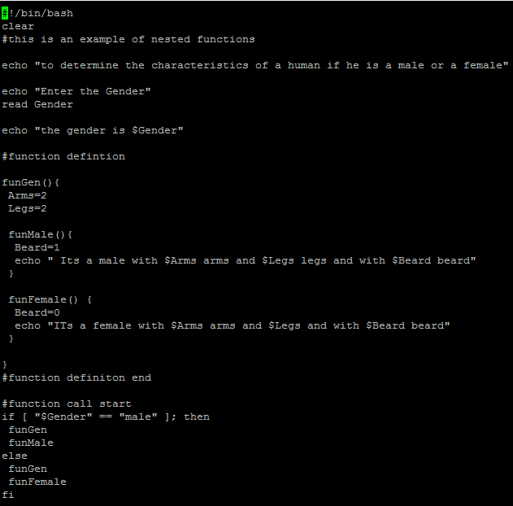

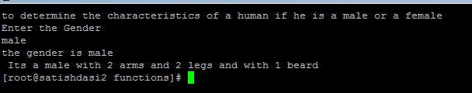

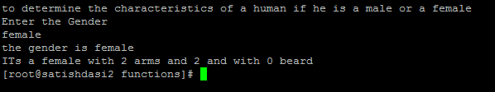

**Lecture: Function Return and Exit**



**This checks if the THIRD value isn’t empty. –z means empty but we have put a not in front then this statement checks if the THIRD variable is not empty. We are creating a function which checks if we the user has passed all the third parameters and inorder to make this sure we are checking the value of the THIRD variable value for not null. IF its not null that means the user must have atleast passed the 3 parameters via the commandline as**

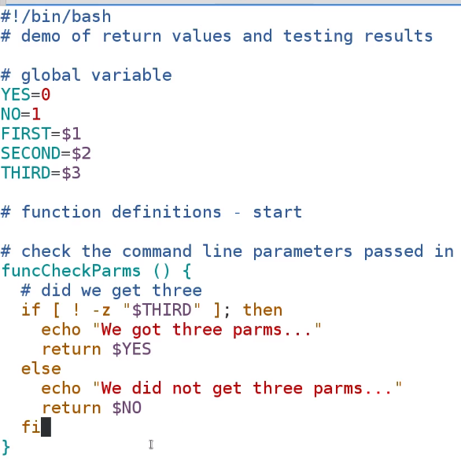

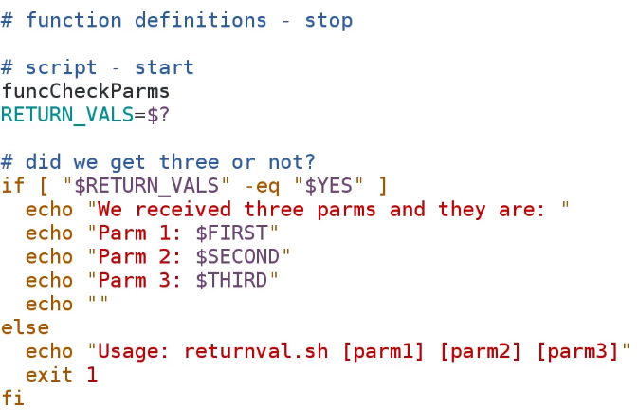

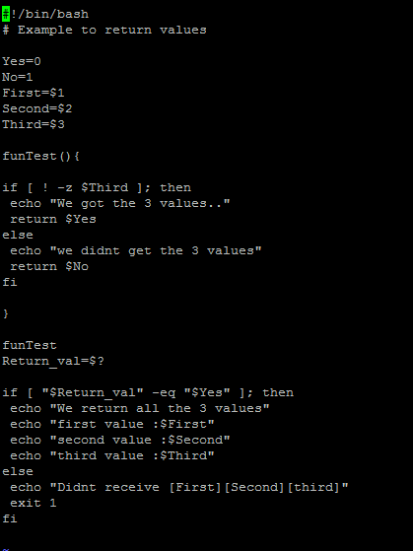



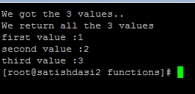

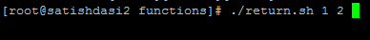

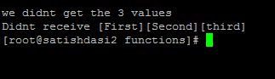

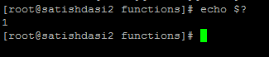

**But if comment out the exit 1 line as**

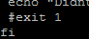

**And rerun the script as**



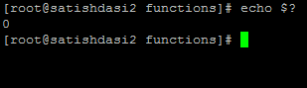

**We get 0 because the script didn’t error out. The script is just fine, there is nothing wrong with the script as none of the commands failed so it normally would return a zero to the environment to let us know hey everything went ok.**

**By giving the line exit 1 im forcing it to give a exit status as 1 if the else condition runs.**

**Samples/Use Cases**

**Lecture: Using the InfoBox**



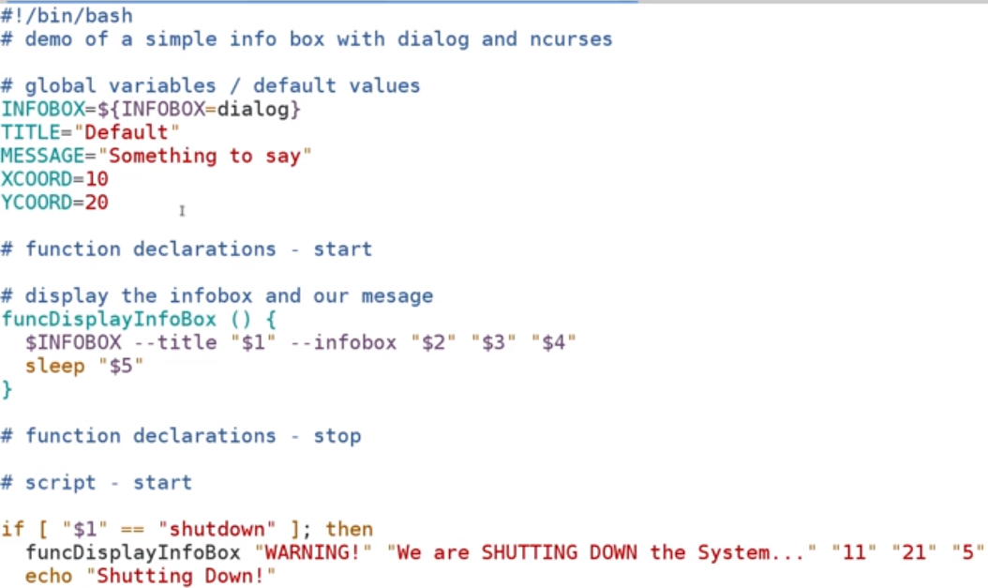

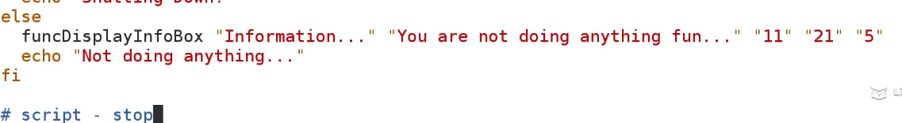

**Lecture: Display a MessageBox for Confirmation**

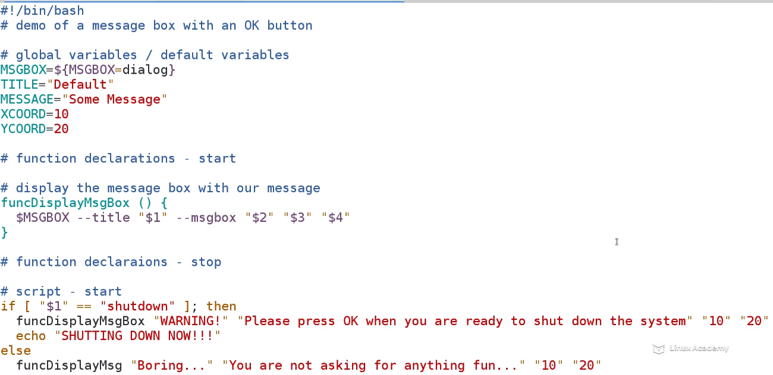

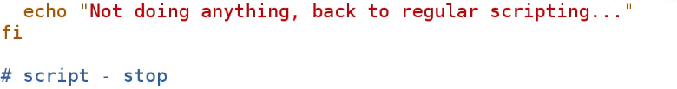

There is an error ,we need to edit the function name to as



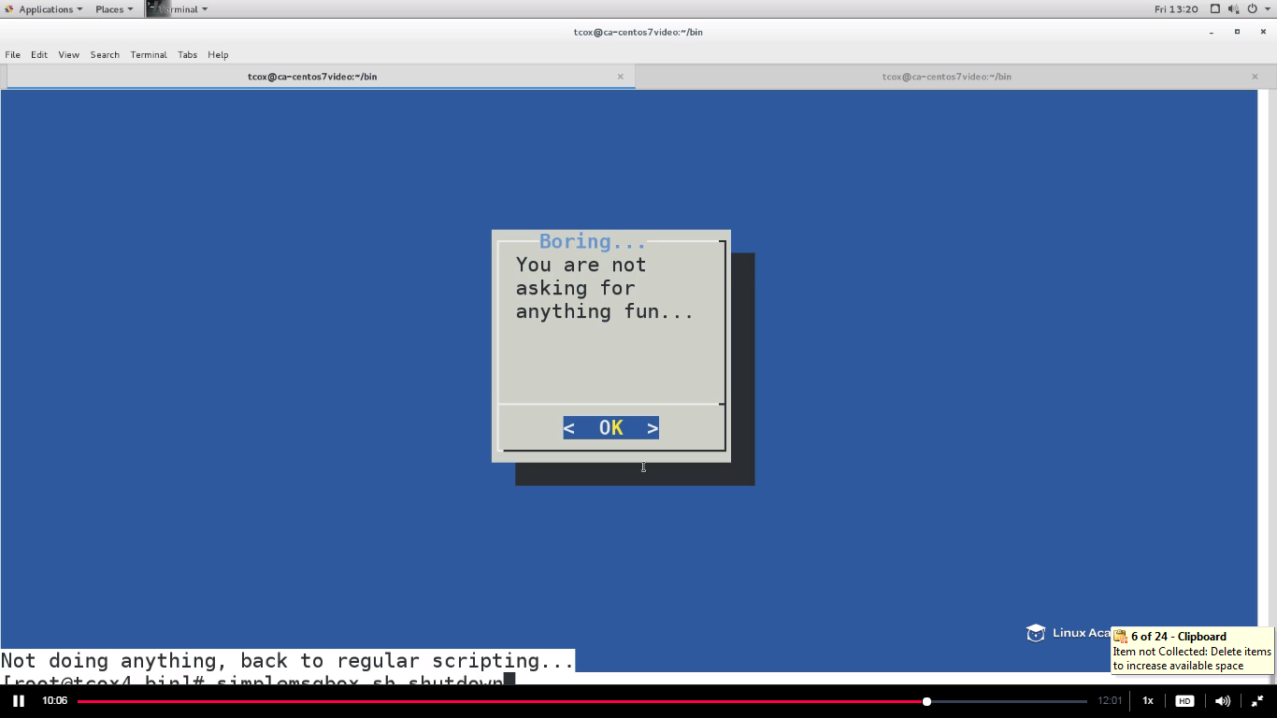

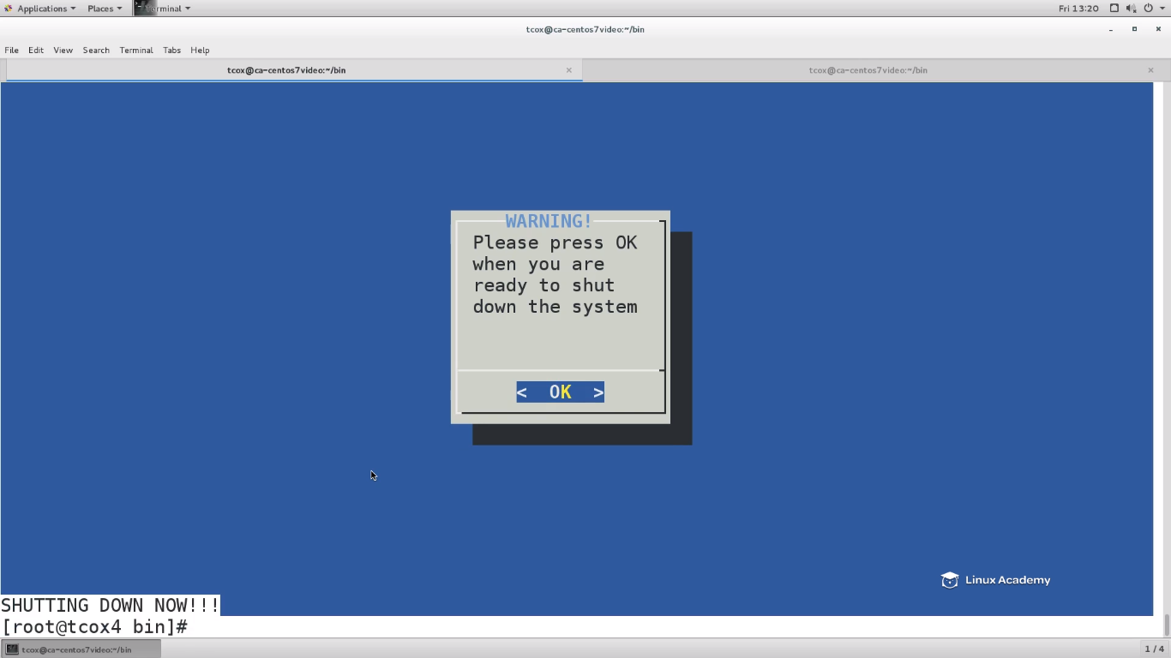

**Lecture: Advanced UI - Building a Menu System**

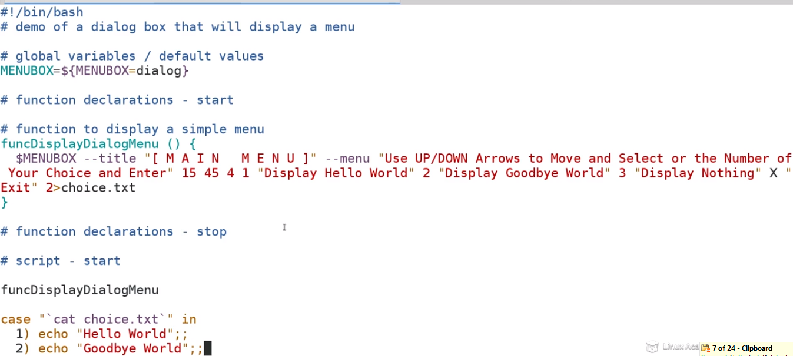

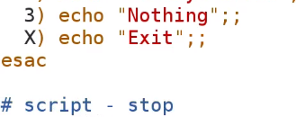

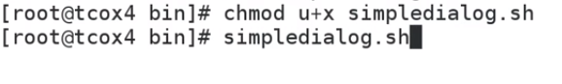

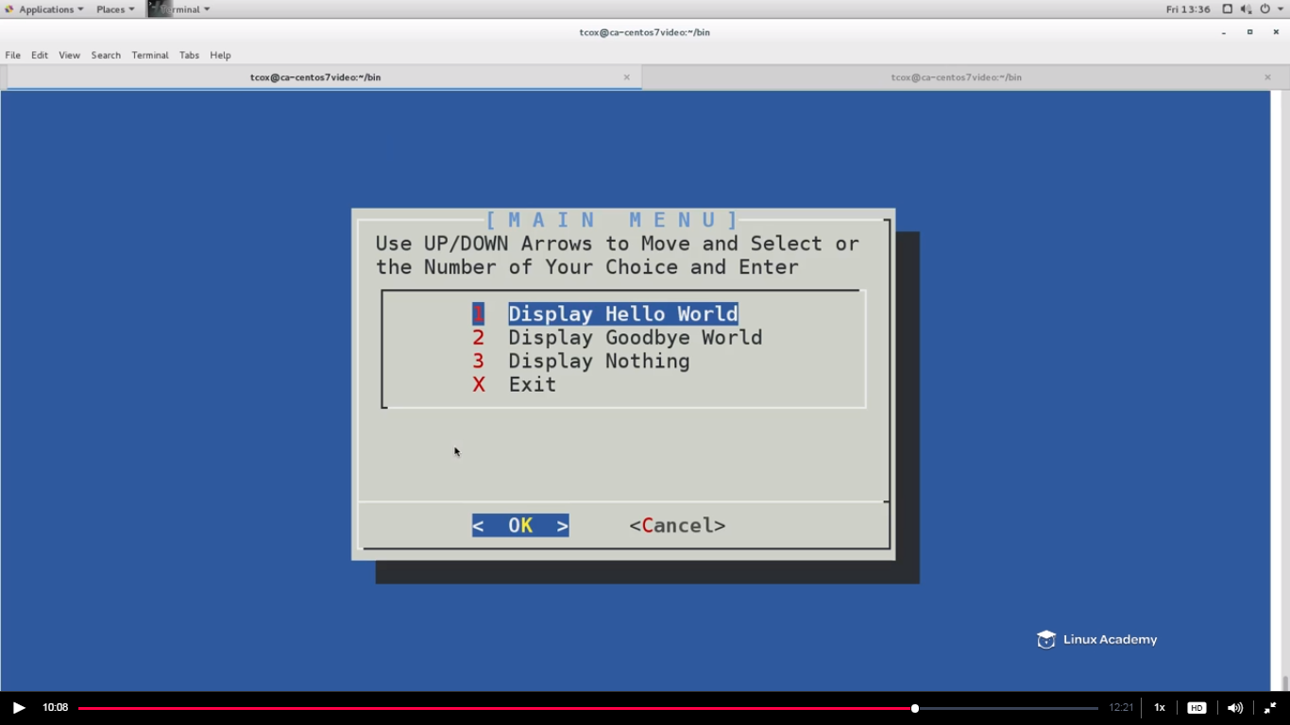

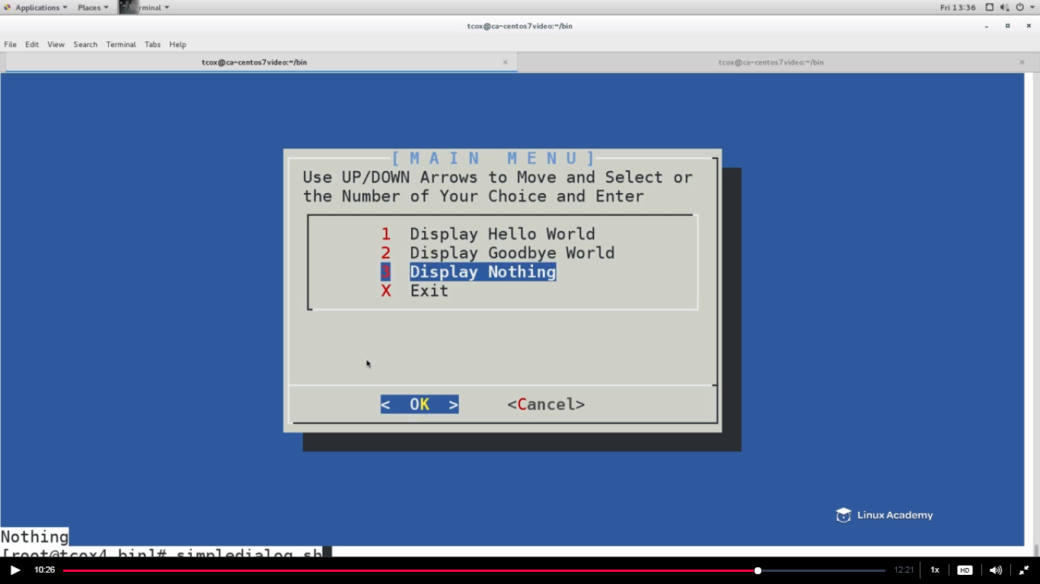

**Lecture: Quickly Checking Command Line Parameters**

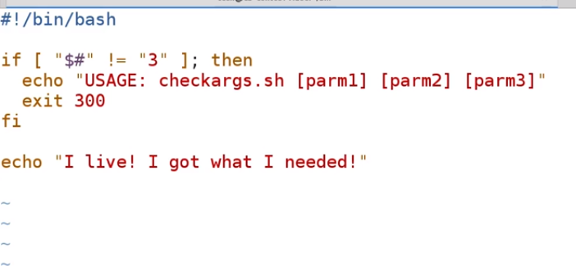

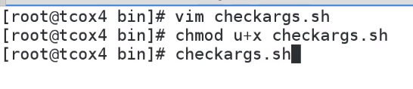

**As we didn’t passed any arguments that’s why we get the error message we defined in our else case.**



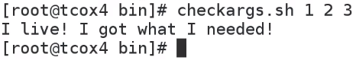

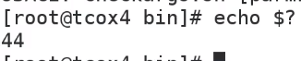

**If we want to check whether we have passed all the 3 parameters or not in just one line then we need to do the below**

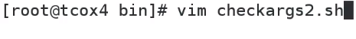

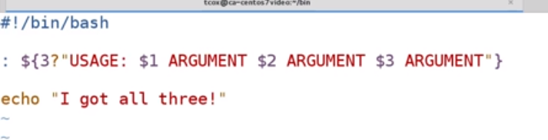

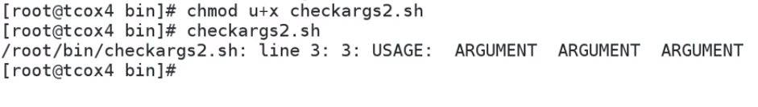



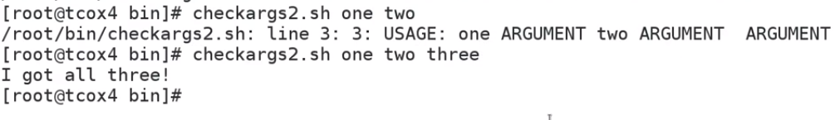

**So when I give all the three arguments then we receive the success message which we have defined. This is the shortcut way to test our arguments.**



**Lecture: Building a Document Generator**

